C# - Delegates
C# delegates are similar to pointers to functions, in C or C++. A delegate is a reference type variable that holds the reference to a method. The reference can be changed at runtime.
Delegates are especially used for implementing events and the call-back methods. All delegates are implicitly derived from the System.Delegate class.

Declaring Delegates
Delegate declaration determines the methods that can be referenced by the delegate. A delegate can refer to a method, which has the same signature as that of the delegate.
For example, consider a delegate −
public delegate int MyDelegate (string s);
The preceding delegate can be used to reference any method that has a single string parameter and returns an int type variable.
Syntax for delegate declaration is −
delegate <return type> <delegate-name> <parameter list>

Instantiating Delegates
Once a delegate type is declared, a delegate object must be created with the new keyword and be associated with a particular method. When creating a delegate, the argument passed to the new expression is written similar to a method call, but without the arguments to the method. For example −
public delegate void printString(string s);
...
printString ps1 = new printString(WriteToScreen);
printString ps2 = new printString(WriteToFile);
Following example demonstrates declaration, instantiation, and use of a delegate that can be used to reference methods that take an integer parameter and returns an integer value.
using System;

delegate int NumberChanger(int n);
namespace DelegateAppl {

class TestDelegate {
static int num = 10;

public static int AddNum(int p) {
num += p;
return num;
}
public static int MultNum(int q) {
num *= q;
return num;
}
public static int getNum() {
return num;
}
static void Main(string[] args) {
//create delegate instances
NumberChanger nc1 = new NumberChanger(AddNum);
NumberChanger nc2 = new NumberChanger(MultNum);

//calling the methods using the delegate objects
nc1(25);
Console.WriteLine("Value of Num: {0}", getNum());
nc2(5);
Console.WriteLine("Value of Num: {0}", getNum());
Console.ReadKey();
}
}
}

When the above code is compiled and executed, it produces the following result −
Value of Num: 35
Value of Num: 175

Multicasting of a Delegate
Delegate objects can be composed using the "+" operator. A composed delegate calls the two delegates it was composed from. Only delegates of the same type can be composed. The "-" operator can be used to remove a component delegate from a composed delegate.
Using this property of delegates you can create an invocation list of methods that will be called when a delegate is invoked. This is called multicasting of a delegate. The following program demonstrates multicasting of a delegate −
using System;

delegate int NumberChanger(int n);
namespace AllAppDemo
{
class TestDelegate
{
static int num = 10;

public static int AddNum(int p)
{
num += p;
return num;
}
public static int MultNum(int q)
{
num *= q;
return num;
}
public static int getNum()
{
return num;
}
static void Main(string[] args)
{
//create delegate instances
NumberChanger nc;
NumberChanger nc1 = new NumberChanger(AddNum);
NumberChanger nc2 = new NumberChanger(MultNum);

nc = nc1;
nc += nc2;

//calling multicast
nc(5);
Console.WriteLine("Value of Num: {0}", getNum());
Console.ReadKey();
}
}
}

Using Delegates
The following example demonstrates the use of delegate. The delegate printString can be used to reference method that takes a string as input and returns nothing.
We use this delegate to call two methods, the first prints the string to the console, and the second one prints it to a file using System;
using System.IO;

namespace DelegateAppl {

class PrintString {
static FileStream fs;
static StreamWriter sw;

// delegate declaration
public delegate void printString(string s);

// this method prints to the console
public static void WriteToScreen(string str)
{
Console.WriteLine("The String is: {0}", str);
}

//this method prints to a file
public static void WriteToFile(string s) {
fs = new FileStream("c:\\message.txt",
FileMode.Append, FileAccess.Write);
sw = new StreamWriter(fs);
sw.WriteLine(s);
sw.Flush();
sw.Close();
fs.Close();
}

// this method takes the delegate as parameter and uses it to
// call the methods as required
public static void sendString(printString ps) {
ps("Hello World");
}

static void Main(string[] args) {
printString ps1 = new printString(WriteToScreen);
printString ps2 = new printString(WriteToFile);
sendString(ps1);
sendString(ps2);
Console.ReadKey();
}
}
}

C# Events With Programming Example
In this chapter you will learn:
- What is Events?
- How Events work with Delegates?
- What is Publisher-Subscriber Model?
- How to use Events with Delegates?

WHAT IS EVENTS?
Events are nothing just a user action. For example
- When you click with the mouse – It is mouse click events.
- When you press any key in keyboard – It is KeyPress events
- When you refresh your webpage – It is page load events
- When you move mouse cursor – It is mouse hover events etc.
So when you take any action like a key press, mouse movements, clicks etc an event raised. Let me clear more about it. For example, you filled an online form and click on submit button.
- In the background button_click() event raised.
- This event calls and execute an associated function Submit_Click().
- This function processes your request and submits page information to database.

HOW EVENTS WORK WITH DELEGATES?
Delegates are used to reference a method. An Event is associated with Event Handler using Delegates. When an Event raise, it sends a signal to delegates and delegates executes the right function.

WHAT IS PUBLISHER-SUBSCRIBER MODEL?
There are two parts in any event handling program. One part is Publisher that contains definition of events and delegates and another part is Subscriber that accepts the event and provides an event handler.

IMPORTANT FACT ABOUT EVENTS
- An Event is created using event keyword.
- An Event has no return type and it is always void.
- All events are based on delegates.
- All the published events must have a listening object.
- All Events should be defined starting with “On” keyword.
Let's understand all these theory using Programming Example
Before seeing the programming examples you must know the sequential steps to manipulate events.
Step 1: Define a Delegate
Step 2: Define an Event with same name of Delegates.
Step 3: Define an Event Handler that respond when event raised.
Step 4: You must have method ready for delegates.

PROGRAMMING EXAMPLE:
This program simply adds two numbers. Only condition is if the sum of number is odd it fires an event that print a message using delegates.
//This is Publisher Class
class AddTwoNumbers
{
public delegate void dg_OddNumber(); //Declared Delegate
public event dg_OddNumber ev_OddNumber; //Declared Events

public void Add()
{
int result;
result = 5 + 4;
Console.WriteLine(result.ToString());
//Check if result is odd number then raise event
if((result % 2 != 0) && (ev_OddNumber != null))
{
ev_OddNumber(); //Raised Event
}
}
}
//This is Subscriber Class
class Program
{
static void Main(string[] args)
{
AddTwoNumbers a = new AddTwoNumbers();
//Event gets binded with delegates
a.ev_OddNumber += new AddTwoNumbers.dg_OddNumber(EventMessage);
a.Add();
Console.Read();
}
//Delegates calls this method when event raised.
static void EventMessage()
{
Console.WriteLine("********Event Executed : This is Odd Number**********");
}
}

Output:
9
********Event Executed : This is Odd Number**********

EXPLANATION
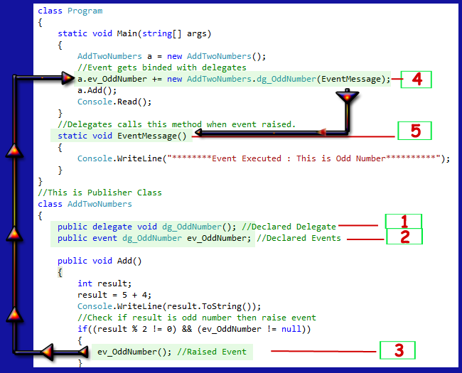
See this picture. There is some marking on the code. We will go through the marking and understand the process.

- Delegate Created
public delegate void dg_OddNumber();
- Event Created
public event dg_OddNumber ev_OddNumber;
- ev_OddNumber() event gets executed if the odd number is found.
- In the AddTwoNumbers class there is a function void Add() that adds two numbers. If the sum of the number is Odd it raised an ev_OddNumber event.In the main function this ev_OddNumber event handler calls the delegates
a.ev_OddNumber += new AddTwoNumbers.dg_OddNumber(EventMessage);
- Then finally delegate executes the function.
- static void EventMessage()
- {
- Console.WriteLine("********Event Executed : This is Odd Number**********");
}

Func, Action And Predicate Delegates In C#

Introduction

We learned what delegates are in this article.

Whenever we use delegates, we have to declare a delegate then initialize it, then we call a method with a reference variable.

In order to get rid of all the first steps, we can directly use Func, Action, or Predicate delegates.
- The Func delegate takes zero, one or more input parameters, and returns a value (with its out parameter).
- Action takes zero, one or more input parameters, but does not return anything.
- Predicate is a special kind of Func. It represents a method that contains a set of criteria mostly defined inside an if condition and checks whether the passed parameter meets those criteria or not.
It takes one input parameter and returns a boolean - true or false.

Note
You can use all three of them with anonymous methods and lambda expressions.

Let's first learn the Func delegate.

Syntax 1

One input parameter and one return parameter.
- public delegate TResult Func<int T, out TResult>(T arg);
Syntax 2

Two input parameters and one return parameter.
- public delegate TResult Func<in T1, in T2, out TResult>(T1 arg, T2 arg2)
The last parameter in the angle brackets <> is considered as the return type and remaining parameters are considered as input parameter types.
It can have 0 - 16 input parameters.

Func with 0 parameters
- Func<int> SomeMethodName;
It still has one parameter, it is a return type because func always return something.
- class Program
- {
- static void Main(string[] args)
- {
- Func<int,int,int> Addition = AddNumbers;
- int result = Addition(10, 20);
- Console.WriteLine($"Addition = {result}");
- }

- private static int AddNumbers(int param1, int param2 )
- {
- return param1 + param2;
- }
}
using System;

namespace GenericCollExceptionHandlingDemo
{
public class Program
{
static void Main(string[] args)
{
Func<int, int, int> Addition = AddNumbers;
int result = Addition(10, 20);
Console.WriteLine($"Addition = {result}");

Console.ReadKey();
}

private static int AddNumbers(int param1, int param2)
{
return param1 + param2;
}

}
}

Func with an Anonymous Method:
- Func<int,int,int> Addition = delegate (int param1, int param2)
- {
- return param1 + param2;
- };
- int result = Addition(10, 20);
- Console.WriteLine($"Addition = {result}");

using System;

namespace GenericCollExceptionHandlingDemo
{
public class Program
{
static void Main(string[] args)
{

//Action with an Anonymous method:
int result = 0;
Action<int, int> Addition = delegate (int param1, int param2)
{
result = param1 + param2;
};
Addition(10, 20);
Console.WriteLine($"Addition = {result}");

Console.ReadKey();
}

Func with Lambda Expression:
- Func<int, int, int> Addition = (param1, param2) => param1 + param2;
- int result = Addition(10, 20);
- Console.WriteLine($"Addition = {result}");

static void Main(string[] args)
{

Func<int, int, int> Addition = (param1, param2) => param1 + param2;
int result = Addition(10, 20);
Console.WriteLine($"Addition = {result}");

Console.ReadKey();
}

Action delegate

Here, method AddNumbers takes 2 parameters but returns nothing. The results are assigned to an instance variable result.

Even an ion delegate can have 0 - 16 input parameters.
- private static int result;
- static void Main(string[] args)
- {
- Action<int, int> Addition = AddNumbers;
- Addition(10, 20);
- Console.WriteLine($"Addition = {result}");
- }

- private static void AddNumbers(int param1, int param2 )
- {
- result = param1 + param2;
- }

using System;

namespace GenericCollExceptionHandlingDemo
{
public class Program
{
private static int result;
static void Main(string[] args)
{
Action<int, int> Addition = AddNumbers;
Addition(10, 20);
Console.WriteLine($"Addition = {result}");
Console.ReadKey();
}

private static void AddNumbers(int param1, int param2)
{
result= param1 + param2;
}

}
}

Action with an Anonymous method:
- private static int result;
- static void Main(string[] args)
- {
- Action<int, int> Addition = delegate (int param1, int param2)
- {
- result = param1 + param2;
- };
- Addition(10, 20);
- Console.WriteLine($"Addition = {result}");
- }

using System;

namespace GenericCollExceptionHandlingDemo
{
public class Program
{
private static int result;
static void Main(string[] args)
{
Action<int, int> Addition = delegate (int param1, int param2)
{
result = param1 + param2;
};
Addition(10, 20);
Console.WriteLine($"Addition = {result}");

Console.ReadKey();
}

//private static void AddNumbers(int param1, int param2)
//{
// result= param1 + param2;
//}

}
}

Action with a Lambda expression:
- private static int result;
- static void Main(string[] args)
- {
- Action<int, int> Addition = (param1, param2) => result = param1 + param2; ;
- Addition(10, 20);
- Console.WriteLine($"Addition = {result}");
- }

using System;

namespace GenericCollExceptionHandlingDemo
{
public class Program
{
private static int result;
static void Main(string[] args)
{
Action<int, int> Addition = (param1, param2) => result = param1 + param2; ;
Addition(10, 20);
Console.WriteLine($"Addition = {result}");
Console.ReadKey();
}

}
}

Predicate delegate

Syntax difference between predicate & func is that here in predicate, you don't specify a return type because it is always a bool.

Let's check if the phone is an iPhone or not...
- class Program
- {
- static void Main(string[] args)
- {
- Predicate<string> CheckIfApple = IsApple;
- bool result = IsApple("I Phone X");
- if(result)
- Console.WriteLine("It's an IPhone");
- }

- private static bool IsApple(string modelName)
- {
- if (modelName == "I Phone X")
- return true;
- else
- return false;
- }
- }

using System;

namespace GenericCollExceptionHandlingDemo
{
public class Program
{
private static int result;
static void Main(string[] args)
{
Predicate<string> CheckIfApple = IsApple;
bool result = IsApple("I Phone X");
if (result)
Console.WriteLine("It's an IPhone");

Console.ReadKey();
}

private static bool IsApple(string modelName)
{
if (modelName == "I Phone X")
return true;
else
return false;
}

}
}

A predicate with Anonymous method:
- Predicate < string > CheckIfApple = delegate(string modelName) {
- if (modelName == "I Phone X") return true;
- else return false;
- };
- bool result = CheckIfApple("I Phone X");
- if (result) Console.WriteLine("It's an IPhone");

using System;

namespace GenericCollExceptionHandlingDemo
{
public class Program
{
private static int result;
static void Main(string[] args)
{
Predicate<string> CheckIfApple = delegate (string modelName) {
if (modelName == "I Phone X") return true;
else return false;
};
bool result = CheckIfApple("I Phone X");
if (result) Console.WriteLine("It's an IPhone");

Console.ReadKey();
}

}
}

A predicate with Lambda expressions:
- Predicate < string > CheckIfApple = modelName => {
- if (modelName == "I Phone X") return true;
- else return false;
- };
- bool result = CheckIfApple("I Phone X");
- if (result) Console.WriteLine("It's an IPhone");

using System;

namespace GenericCollExceptionHandlingDemo
{
public class Program
{
private static int result;
static void Main(string[] args)
{
Predicate<string> CheckIfApple = modelName => {
if (modelName == "I Phone X") return true;
else return false;
};
bool result = CheckIfApple("I Phone X");
if (result) Console.WriteLine("It's an IPhone");

Console.ReadKey();
}

}
}

Wonderful!

That's how you can directly use ready-made delegates without having them declared.

C# - Anonymous Method
As the name suggests, an anonymous method is a method without a name. Anonymous methods in C# can be defined using the delegate keyword and can be assigned to a variable of delegate type.
using System;
public class Program
{
public delegate void Print(int value);
public static void Main()
{
Print print = delegate(int val)
{
Console.WriteLine("Inside Anonymous method. Value: {0}", val);
};
print(100);
}
}

Anonymous methods can also be passed to a method that accepts the delegate as a parameter.
In the following example, PrintHelperMethod() takes the first parameters of the Print delegate:
using System;
public delegate void Print(int value);
public class Program
{
public static void PrintHelperMethod(Print printDel,int val)
{
val += 10;
printDel(val);
}
public static void Main(string[] args)
{
PrintHelperMethod(delegate(int val) { Console.WriteLine("Anonymous method:
{0}", val); }, 100);
}
}

Anonymous Method Limitations
- It cannot contain jump statement like goto, break or continue.
- It cannot access ref or out parameter of an outer method.
- It cannot have or access unsafe code.
- It cannot be used on the left side of the is operator
Points to Remember :
- Anonymous method can be defined using the delegate keyword
- Anonymous method must be assigned to a delegate.
- Anonymous method can access outer variables or functions.
- Anonymous method can be passed as a parameter.
- Anonymous method can be used as event handlers.

Anatomy of the Lambda Expression
C# 3.0(.NET 3.5) introduced the lambda expression along with LINQ. The lambda expression is a shorter way of representing anonymous method using some special syntax.
For example, following anonymous method checks if student is teenager or not:
using System;
public class Program
{
delegate bool IsTeenAger(Student stud);
public static void Main()
{
IsTeenAger isTeenAger = delegate(Student s) { return s.Age > 12 && s.Age < 20; };

Student stud = new Student() { Age = 25 };

Console.WriteLine(isTeenAger(stud));
}
}
public class Student{

public int Id { get; set; }
public string Name { get; set; }
public int Age { get; set; }
}
Result False
The above anonymous method can be represented using a Lambda Expression in C#
public class Program
{
delegate bool IsTeenAger(Student stud);

public static void Main()
{
IsTeenAger isTeenAger = s => s.Age > 12 && s.Age < 20;

Student stud = new Student() { Age = 25 };

Console.WriteLine(isTeenAger(stud));

}
}

public class Student{

public int Id { get; set; }
public string Name { get; set; }
public int Age { get; set; }
}
Result False
Let's see how the lambda expression evolved from the following anonymous method.
Example: Anonymous method in C#
delegate(Student s) { return s.Age > 12 && s.Age < 20; };
The Lambda expression evolves from anonymous method by first removing the delegate keyword and parameter type and adding a lambda operator =>

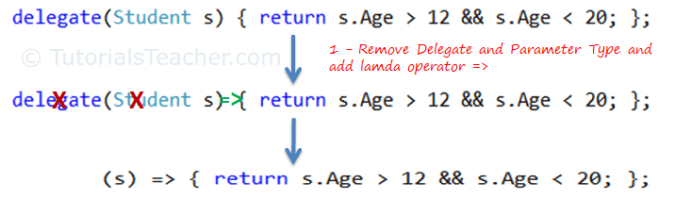
The above lambda expression is absolutely valid, but we don't need the curly braces, return and semicolon if we have only one statement that returns a value. So we can eliminate it.
Also, we can remove parenthesis (), if we have only one parameter.
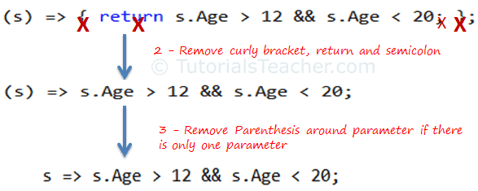
Lambda Expression from Anonymous Method

Thus, we got the lambda expression: s => s.Age > 12 && s.Age < 20 where s is a parameter, => is the lambda operator and s.Age > 12 && s.Age < 20 is the body expression:
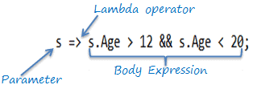
Lambda Expression Structure in C#

Lambda Expression with Multiple Parameters
You can wrap the parameters in parenthesis if you need to pass more than one parameter, as below:
using System;

public class Program
{
delegate bool IsYoungerThan(Student stud, int youngAge);

public static void Main()
{
IsYoungerThan isYoungerThan = (s, youngAge) => s.Age < youngAge;

Student stud = new Student() { Age = 25 };

Console.WriteLine(isYoungerThan(stud, 26));

}
}

public class Student{

public int Id { get; set; }
public string Name { get; set; }
public int Age { get; set; }
}

Lambda Expression without Parameter
It is not necessary to have atleast one parameter in a lambda expression. The lambda expression can be specify without any parameter also.

Example: Lambda Expression without Parameter
using System;

public class Program
{
delegate void Print();

public static void Main()
{
Print print = () => Console.WriteLine("This is parameter less lambda expression");

print();

}
}

Multiple Statements in Lambda Expression Body
You can wrap expressions in curly braces if you want to have more than one statement in the body:
using System;
public class Program
{
delegate bool IsYoungerThan(Student stud, int youngAge);
public static void Main()
{
IsYoungerThan isYoungerThan = (s, youngAge) => {
Console.WriteLine("Lambda expression with multiple statements in the body"); return s.Age < youngAge;
};

Student stud = new Student() { Age = 25 };
Console.WriteLine(isYoungerThan(stud, 26));
}

Lambda expression can also be assigned to built-in delegates such as Func, Action and Predicate.
Anatomy of the Lambda Expression (tutorialsteacher.com)

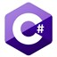
Extension Methods in C#
A C# extension methods allows developers to extend functionality of an existing type without without creating a new derived type, recompiling, or otherwise modifying the original type. C# extension method is a special kind of static method that is called as if it was an instance methods on the extended type. In this article, we will create a class library and we will then extend its functionality from the caller code by implementing extension methods in C#.

C# Extension Method
C# extension method is a static method of a static class, where the "this" modifier is applied to the first parameter. The type of the first parameter will be the type that is extended.
Extension methods are only in scope when you explicitly import the namespace into your source code with a using directive.

First we will discuss the problem and then will rectify the problem using an extension method.
Understanding the problem
1. Add a Class library as per the following screen. We created a Calculator library.
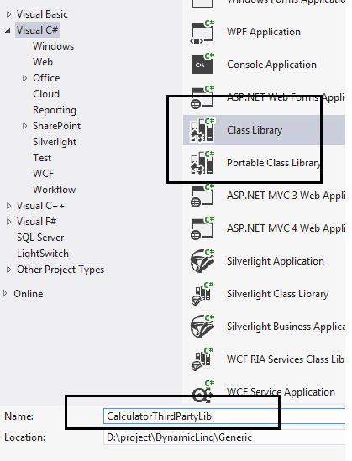
2. Add the Calculator class as per the screen below.

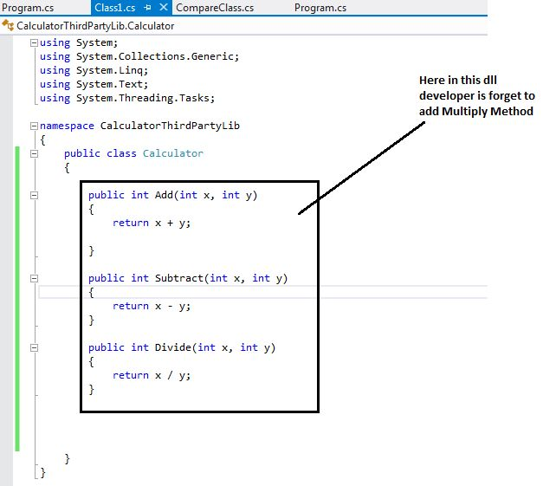
Code
- public class Calculator
- {
- public int Add(int x, int y)
- {
- return x + y;
- }

- public int Subtract(int x, int y)
- {
- return x - y;
- }

- public int Divide(int x, int y)
- {
- return x / y;
- }
- }
Understanding the code
- We created a class library for calculator
- The library contains Add, Subtract and Divide methods
- By mistake the developer forget to add a Multiply method
Build and run the library.
3. Consuming Library (Creation of client)
Create a client application, a console application to consume this library. We call it CalculatorClient as shown below:
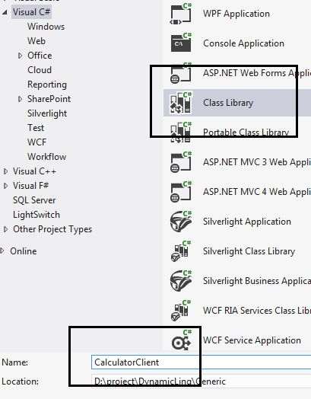
4. Add a refrence of the Calculator library as created above.
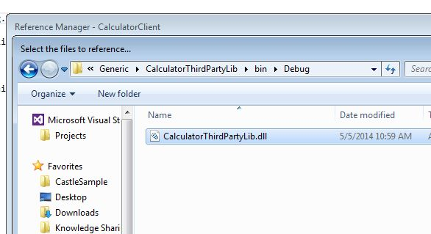
5. Add a reference to the class file as per the screen below:
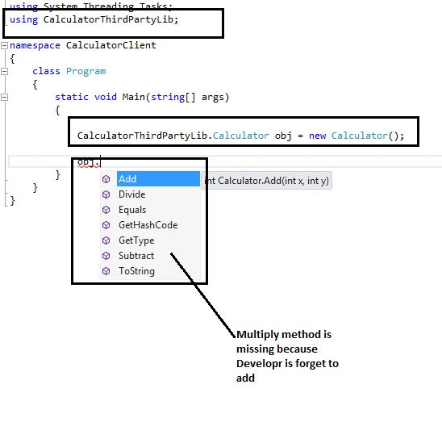
Here in the above code, we created an object of the Calculator class and we can see here Multiply method is not available because the developer forget to add it.
So, now we have multiple options.
Problem

We can raise a request to the third-party DLL company and ask them to add the required functionality. But it is a long process and it would also affect the cost and delivery of the project because we need to wait until we get a new DLL from the company
Solution: we can use an extension method to add a multiply method of this calculator class without modifying the DLL.
6. Add an Extension class. This should be a static class.
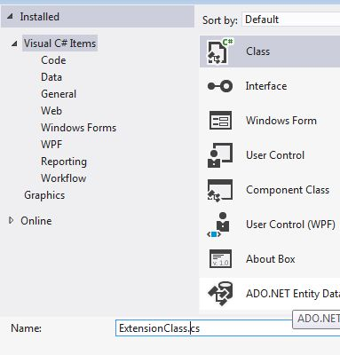
7. We added a Multiply method as per the screen below.

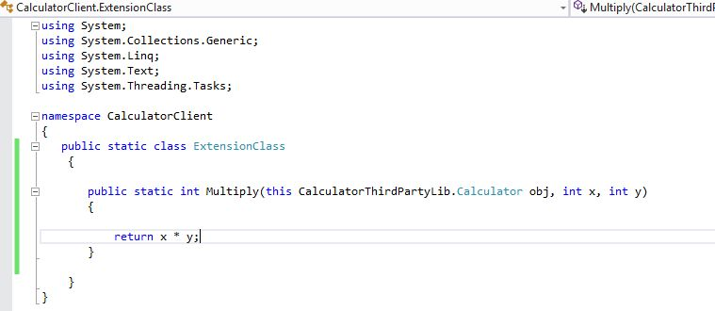
Sample code
- namespace CalculatorClient
- {
- public static class ExtensionClass
- {
- public static int Multiply(this CalculatorThirdPartyLib.Calculator obj, int x, int y)
- {
- return x * y;
- }
- }
- }
8. Compile the code.
9. Now as per the screen below we can see the Multiply method is now available to the object of the Calculator class.

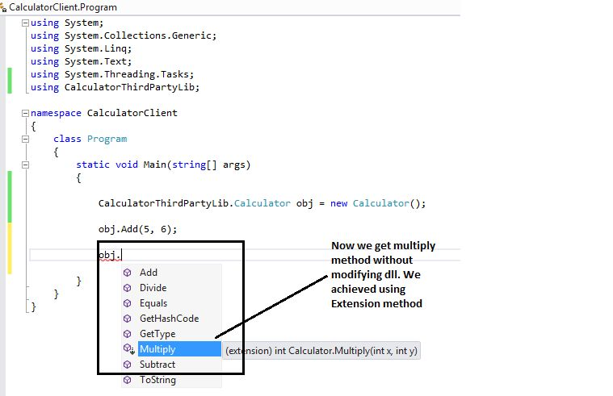
Conclusion
In this article, we learned how to create an extension method and why we actually need extension methods.

.

